Name: Sampreet Klair

Student Number: 145031225

Student Email: [sklair2@myseneca.ca](mailto:sklair2@myseneca.ca)

Date: 15th February, 2024

1. Create a class diagram to support the above case study and Systems Use Case Specifications
2. Create an object level sequence diagram, to support the use case descriptions described above.
3. Include in your word compatible file, what Visual Paradigm would output.

Answer 1:

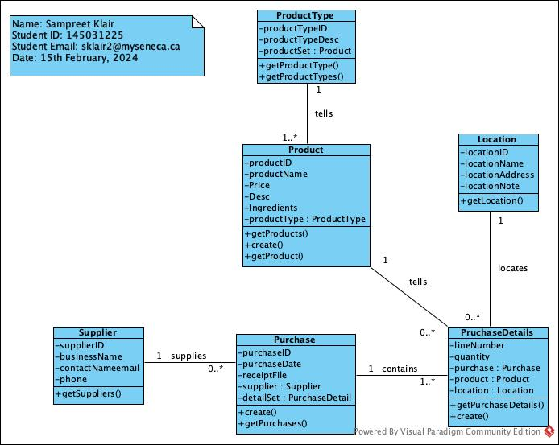

Answer 2:

addProductInfo

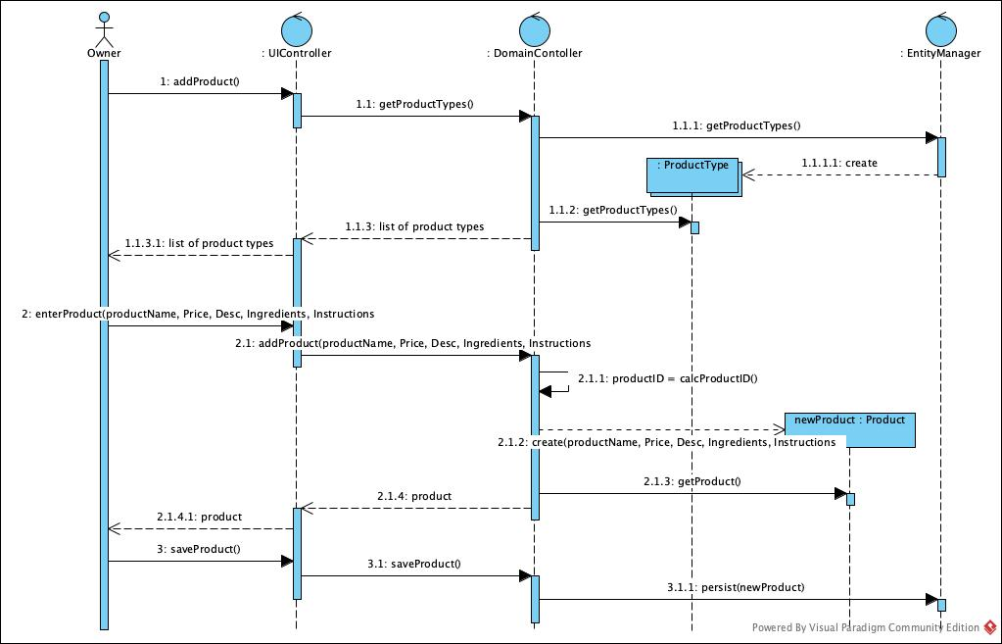

queryProduct

addPurchase

Answer 3:

Public class ProductType{

int productTypeID;

string productTypeDesc;

Product product[];

}

Public class Product{

int productID;

string productName;

double Price;

string Desc;

string Ingredients;

ProductType productType;

}

Public class Supplier{

int supplierID;

string businessName;

string contactNameEmail;

double phone;

}

Public class Purchase{

int purchaseID;

int purchseDate;

string receiptFile;

Supplier supplier;

PurchaseDetail detail[];

}

Public class PurchaseDetails{

int lineNumber;

int quantity;

Purchase purchase;

Product product;

Location location;

}

Public class Location{

int locationID;

string locationName;

string locationAddress;

string locationNote;

}

Public class EntityManager{

// Prototyping for EntityManager operations goes here

}

Public class DomainController{

// Prototyping for DomainContoller operations goes here

}

Public class UIController{

// Prototyping for UIController operations goes here

}